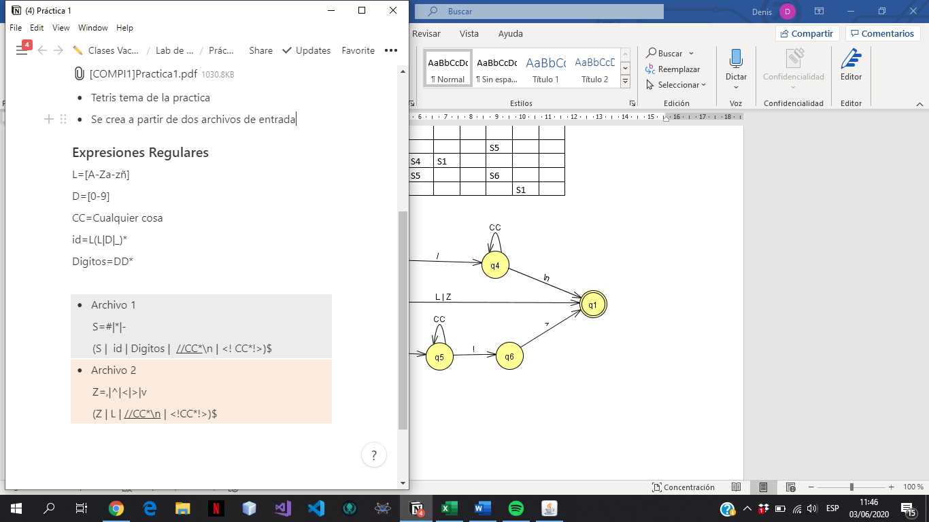

**

|  |  |  |
| --- | --- | --- |
| Símbolo | Número | Siguiente |
| L | 1 | 2,3,4,17 |
| L | 2 | 2,3,4,17 |
| D | 3 | 2,3,4,17 |
| _ | 4 | 2,3,4,17 |
| D | 5 | 6,17 |
| D | 6 | 6,17 |
| / | 7 | 8 |
| / | 8 | 9,10 |
| CC | 9 | 9,10 |
| \n | 10 | 17 |
| < | 11 | 12 |
| ! | 12 | 13,14 |
| CC | 13 | 13,14 |
| ! | 14 | 15 |
| > | 15 | 17 |
| S | 16 | 17 |
| $ | 17 |  |

|  |  |  |  |  |  |  |  |  |  |  |
| --- | --- | --- | --- | --- | --- | --- | --- | --- | --- | --- |
| **Estados** | **L** | **D** | **_** | **/** | **CC** | **\n** | **<** | **!** | **>** | **S** |
| **S0->{1,5,7,11,16}** | S1 | S2 |  | S3 |  |  | S4 |  |  | S5 |
| **\*S1->{2,3,4,17}** | S1 | S1 | S1 |  |  |  |  |  |  |  |
| **\*S2->{6,17}** |  | S2 |  |  |  |  |  |  |  |  |
| **S3->{8}** |  |  |  | S6 |  |  |  |  |  |  |
| **S4->{12}** |  |  |  |  |  |  |  | S7 |  |  |
| **\*S5->{17}** |  |  |  |  |  |  |  |  |  |  |
| **S6->{9,10}** |  |  |  |  | S6 | S5 |  |  |  |  |
| **S7->{13,14}** |  |  |  |  | S7 |  |  | S8 |  |  |
| **S8->{15}** |  |  |  |  |  |  |  |  | S5 |  |

**Archivo 2**

|  |  |  |  |  |  |
| --- | --- | --- | --- | --- | --- |
| **Símbolo** | **Número** | | **Siguiente** | | |
| L | 1 | | 12 | | |
| / | 2 | | 3 | | |
| / | 3 | | 4,5 | | |
| CC | 4 | | 4,5 | | |
| \n | 5 | | 12 | | |
| < | 6 | | 7 | | |
| ! | 7 | | 8,9 | | |
| CC | 8 | | 8,9 | | |
| ! | 9 | | 10 | | |
| > | 10 | | 12 | | |
| Z | 11 | | 12 | | |
| $ | 12 | |  | | |
| **Estado** | | **L** | | **/** | **CC** | | **\n** | **<** | **!** | **>** | **Z** |
| **S0->{1,2,6,11}** | | S1 | | S2 |  | |  | S3 |  |  | S1 |
| **\*S1->{12}** | |  | |  |  | |  |  |  |  |  |
| **S2->{3}** | |  | | S4 |  | |  |  |  |  |  |
| **S3->{7}** | |  | |  |  | |  |  | S5 |  |  |
| **S4->{4,5}** | |  | |  | S4 | | S1 |  |  |  |  |
| **S5->{8,9}** | |  | |  | S5 | |  |  | S6 |  |  |
| **S6->{10}** | |  | |  |  | |  |  |  | S1 |  |

